//1

SELECT *FROM Teachers teacher

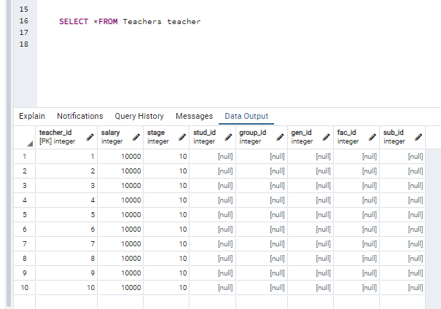

//2

SELECT salary FROM Teachers t INNER JOIN Students1 s ON t.gen_id = s.gen_id;

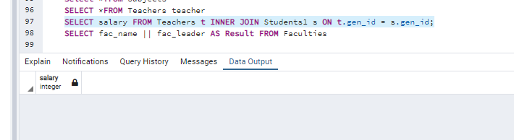

//3

SELECT fac_name || fac_leader AS Result FROM Faculties

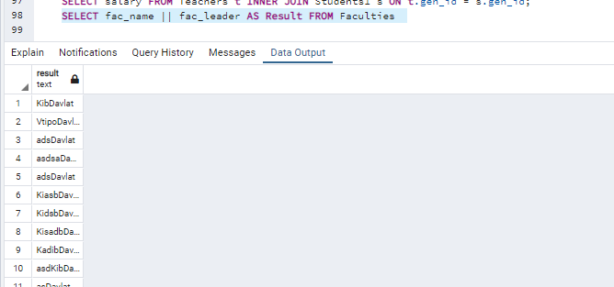

//4

SELECT DISTINCT sub_name FROM Subjects Teachers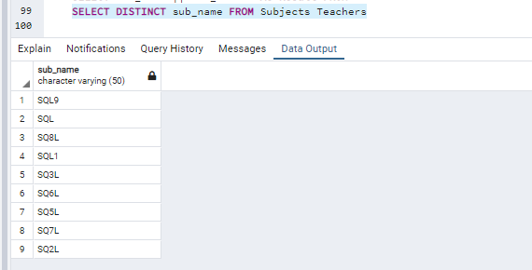

//5

SELECT stud_id FROM Teachers Where stud_id IS NULL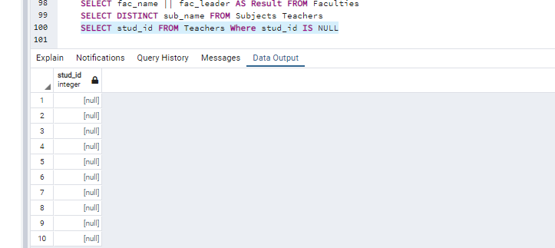

//6

SELECT sub_credits from Subjects where sub_credits >= 2 AND sub_credits <10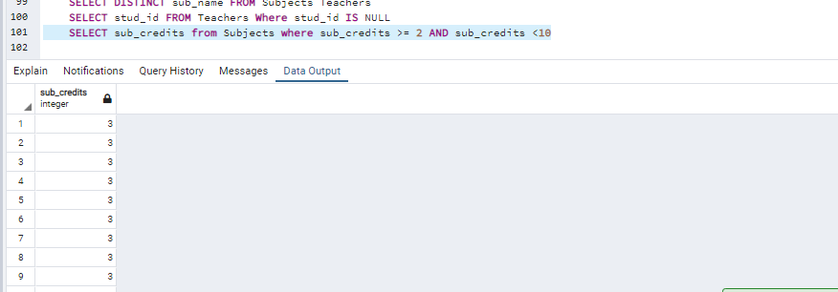

//7

SELECT sub_credits from Subjects where sub_credits BETWEEN 2.0 AND 4.0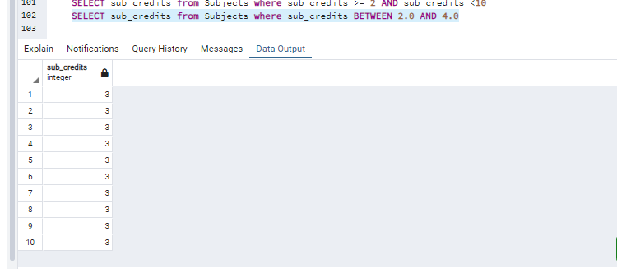

//8

Select sub_name from Subjects where sub_name LIKE 'S%'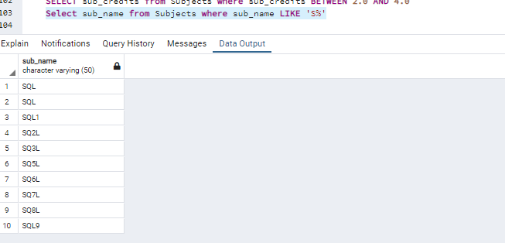

//9

Select sub_name from Subjects where sub_name LIKE 'S_L'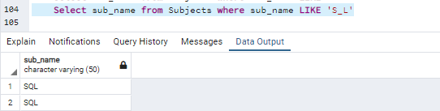

//10

SELECT sub_credits, CAST (3 AS Varchar(14)) from Subjects

